World’s Top Incomes — application-oriented WTID analysis
Packt Cookbook Ch. 3 extended · Alvaredo / Atkinson / Piketty / Saez WTID extract · 26 countries, 1875–2010

Problem Statement
Tax-record top-income series are wide (354 columns), irregularly missing, and defined on shifting units (adults vs tax units, with/without capital gains). A one-off plot of the U.S. top 1% does not travel: a desk that must refresh the file, compare Spain with the United States, or emit an HTML snapshot needs small reusable pieces, not a notebook of unique cells. The question for this extract is concrete: how did U.S. top shares and group averages move over 1913–2008, and is the post-1980 rise large relative to other WTID countries (the comparison drawn in the 2014 Encrucijadas wage-income graphic)?

Solution Strategy
Follow the Cookbook application pattern: csv.DictReader generators → country filter → (year, value) time series → compose line / bar / stack helpers → mean-normalize and capital-gains deltas → pandas alternate for the same numbers → Dialnet-style 1980-vs-latest cross-section → endpoint-noise simulation → four-audience write-up. Stay on the excluding-CG headline series unless the lift chart is the point. Record units from notes.csv (U.S. averages are 2008 USD).

Solution
U.S. top 1% share of total fiscal income: 17.96% (1913) → 8.18% (1980) → 18.29% (2007) → 17.67% (2008). Top 10% (from 1917): 40.29% → 32.87% (1980) → 45.51% (2007). Top 0.1%: 8.62% → 2.23% (1980) → 8.23% (2007). Real average income per tax unit: $14.6k → $40.7k → $54.1k → $51.3k. Mean-normalized paths show the upper tail swinging farther than the top decile. Capital-gains lift is cyclical (booms 1999–2000 and mid-2000s). Cross-country total-income Top 1% change ~1980 to latest ≤2010: United States +9.5 pp; Norway +3.2; Ireland +3.7; Sweden +2.7; Italy +2.5; Japan +2.0; France +1.3; Spain +0.9. Direction matches Dialnet; levels differ because that article used wages only.
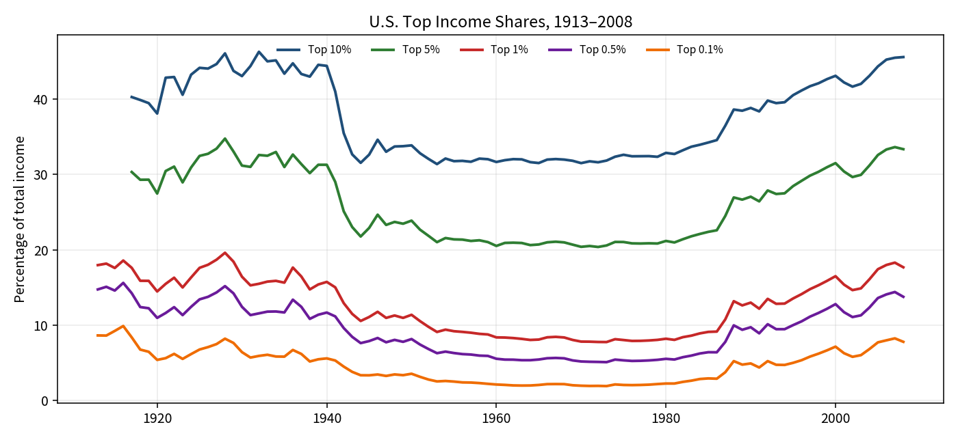
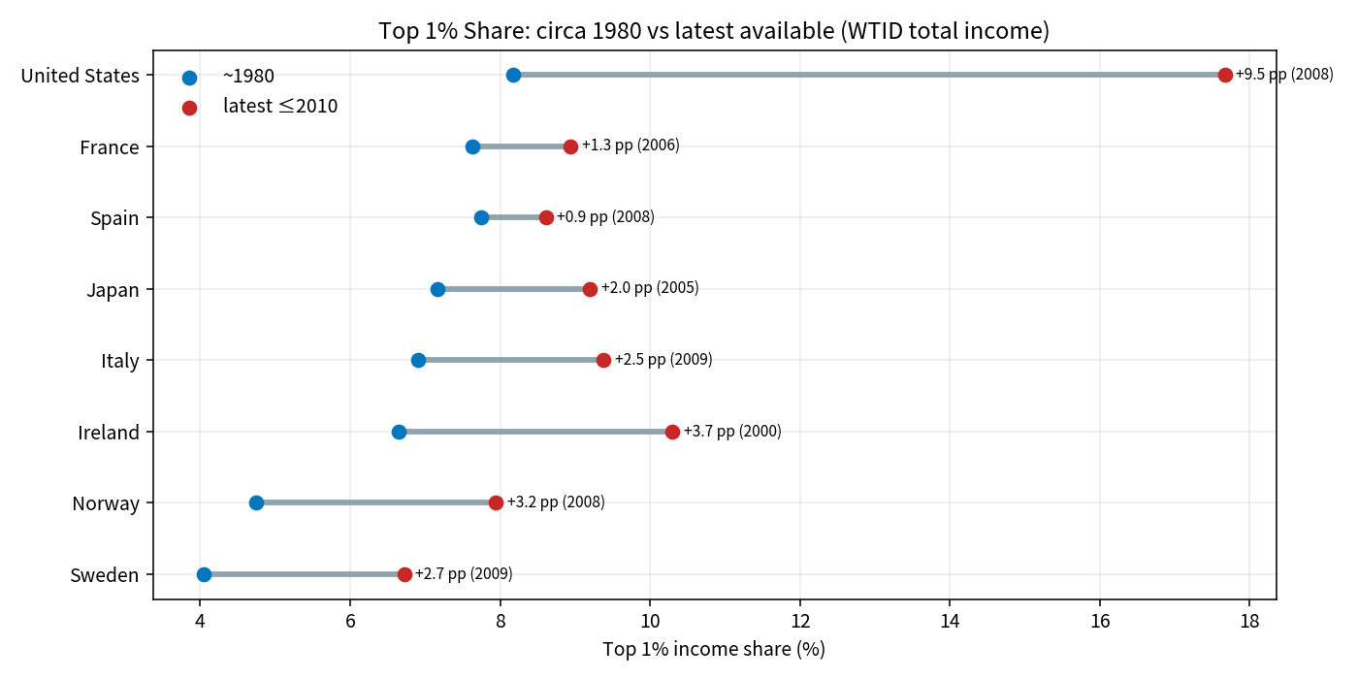

Key Takeaways
1. The U.S. upper tail recovered its pre-war share by 2007; 2008 cut the last year, not the post-1980 regime.
2. Nested fractiles move together; mean-normalization is what reveals that the top 0.1% is the volatile piece.
3. “Including capital gains” is a different ranking, not a plus-up of the same people — use the lift chart, do not invent a CG residual for a fixed group.
4. Spain’s total-income Top 1% barely moved (+0.9 pp); the U.S. move is an order of magnitude larger on the same file. Measurement noise of 0.3 pp does not erase the U.S. jump and can erase Spain’s.
5. Generators + named helpers are the product: the same functions feed the skeleton drills, the HTML mini-report, and the next country file. Pandas is the audit path, not a competing analysis.

